LECTURE 13
MAIN MEMORY

1. What is Fragmentation?
Definition
Fragmentation is the inefficient use of memory that leads to wasted space.
Types of Fragmentation
Internal Fragmentation
- Happens when allocated memory is larger than required
- Unused space remains inside the allocated block
- Occurs in fixed-size allocation (paging)
Example:
Process needs 6 KB but gets 8 KB → 2 KB wasted
External Fragmentation
- Happens when free memory is split into small non-contiguous blocks
- Total memory may be enough, but not in one continuous chunk
- Occurs in contiguous allocation
Example:
Free blocks = 2 KB + 3 KB + 1 KB → cannot allocate 5 KB

2. Paging
Definition
Paging is a memory management technique that divides memory into fixed-size blocks to allow non-contiguous allocation.
Basic Concepts
- Logical memory → divided into pages
- Physical memory → divided into frames
- Page size = Frame size
How Paging Works
- CPU generates a logical address
- Address is divided into:
  - Page number (p)
  - Offset (d)
- Page number is used to index the page table
- Page table gives the frame number
- Physical address = frame number + offset
Advantages
- No external fragmentation
- Efficient memory utilization
- Allows processes to be stored non-contiguously
Disadvantages
- Internal fragmentation
- Extra memory access (page table lookup)

3. Paging Model of Logical and Physical Memory (Diagram Explanation)
What is shown in the diagram
The diagram shows how logical memory pages are mapped to physical memory frames using a page table.
Step-by-step Explanation
Logical Memory (Left Side)
- Process is divided into pages:
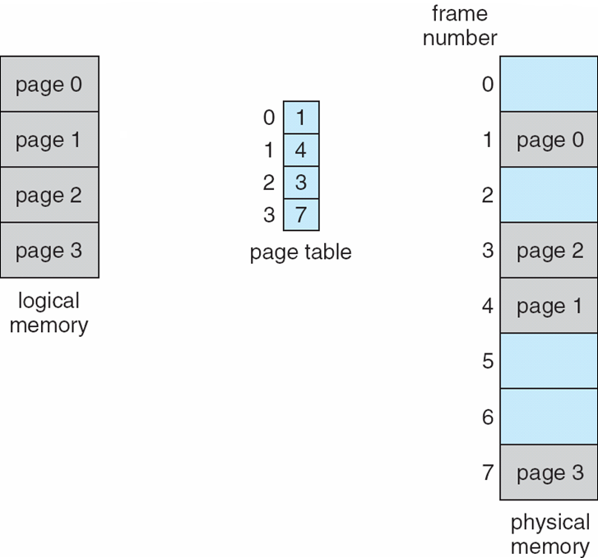
  - Page 0
  - Page 1
  - Page 2
  - Page 3
Page Table (Middle)
- Maps each page to a frame:
  - Page 0 → Frame 1
  - Page 1 → Frame 4
  - Page 2 → Frame 3
  - Page 3 → Frame 7
Physical Memory (Right Side)
- Memory is divided into frames (0–7)
- Pages are placed non-contiguously:
  - Frame 1 → Page 0
  - Frame 4 → Page 1
  - Frame 3 → Page 2
  - Frame 7 → Page 3
What is happening overall
- The process is not stored in one continuous block
- Each page is placed in any available frame
- The page table keeps track of where each page is located
- This enables efficient memory usage and removes external fragmentation

Paging Example
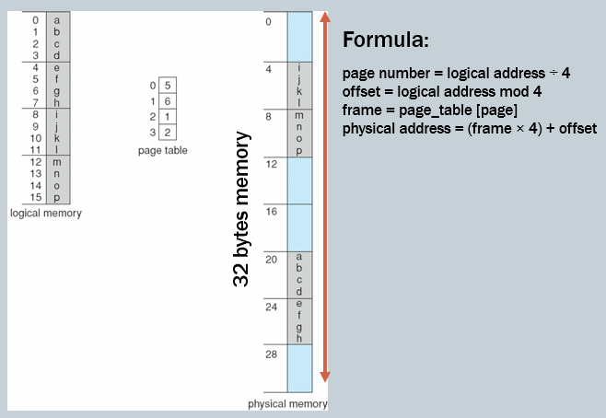
Concept
Paging divides:
- Logical memory → pages
- Physical memory → frames
Both are of equal fixed size
Given
- Page size = 4 bytes
- Logical memory = 16 bytes → 4 pages
- Physical memory = 32 bytes → multiple frames
Page Table Mapping
- Page 0 → Frame 5
- Page 1 → Frame 6
- Page 2 → Frame 1
- Page 3 → Frame 2
How memory is organized
Logical memory (continuous)
- Page 0 → a b c d
- Page 1 → e f g h
- Page 2 → i j k l
- Page 3 → m n o p
Physical memory (non-contiguous)
- Frame 1 → i j k l
- Frame 2 → m n o p
- Frame 5 → a b c d
- Frame 6 → e f g h
Key Idea
- Program appears continuous logically
- Actually stored scattered in memory
- Page table keeps track of locations
Address Calculation Formula
- Page number = logical address ÷ page size
- Offset = logical address mod page size
- Frame = page_table[page]
- Physical address = (frame × page size) + offset
Example
Logical address = 10
- Page = 10 ÷ 4 = 2
- Offset = 10 mod 4 = 2
- Frame = 1
Physical address = (1 × 4) + 2 = 6
Diagram Flow (what is happening)
- Data is divided into pages
- Each page is assigned a frame using page table
- Pages are placed anywhere in physical memory
- Page table connects logical → physical locations

Address Translation Scheme
Concept
Logical address generated by CPU is divided into two parts:
- Page number (p)
- Offset (d)
Meaning of each part
Page Number (p)
- Used as index in page table
- Finds the frame number
Offset (d)
- Specifies exact location inside the page/frame
- Remains unchanged during translation
General Format
Logical Address:
(p, d)
Physical Address:
(f, d)
Address Translation Steps
- CPU generates logical address (p, d)
- Page number (p) is used to access page table
- Page table returns frame number (f)
- Combine frame (f) with offset (d)
- Final result → physical address
Important Note
For:
- Logical address space = 2^m
- Page size = 2^n
Then:
- Page number bits = m − n
- Offset bits = n
Key Idea
- Page number changes (mapped to frame)
- Offset stays same
- This ensures correct position inside data

Paging Hardware
Concept
Paging hardware is responsible for automatic address translation during program execution.
Main Components
CPU
- Generates logical address (p, d)
Page Table
- Stored in main memory
- Maps page number → frame number
Physical Memory
- Contains actual data in frames
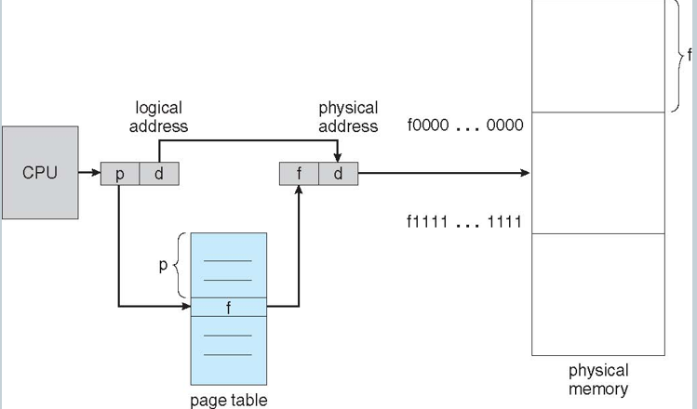
Working (Step-by-Step Flow)
- CPU generates logical address → (p, d)
- Page number (p) is sent to page table
- Page table returns frame number (f)
- Hardware combines:
  - Frame number (f)
  - Offset (d)
- Physical address (f, d) is formed
- Memory is accessed using this physical address
Important Points
- Each memory access requires:
  - One access to page table
  - One access to actual memory
- This increases access time (can be optimized using TLB)

Free Frames
Concept
- Physical memory is divided into frames
- OS keeps track of unused frames in a free-frame list
- When a new process arrives, frames are allocated from this list
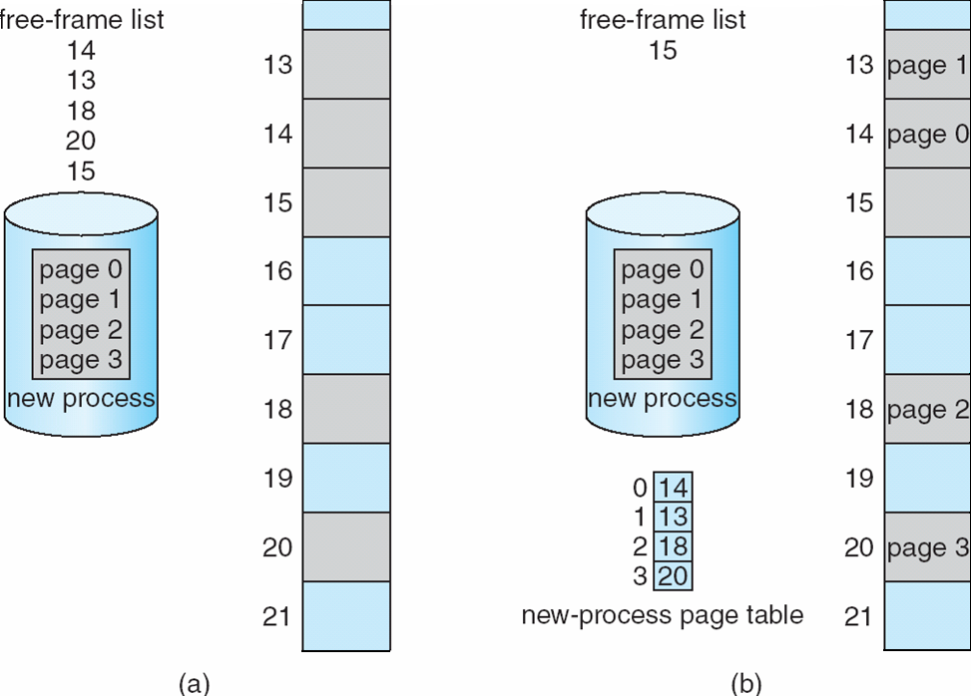
Diagram Flow Explanation
(a) Before Allocation
Step 1: Free-frame list
- Available frames are listed:
  - 14, 13, 18, 20, 15
This list tells which frames are currently empty
Step 2: New process arrives
- Process has 4 pages:
  - Page 0
  - Page 1
  - Page 2
  - Page 3
- These pages are currently not in memory yet
(b) After Allocation
Step 3: Assign frames to pages
OS takes frames from the free-frame list and assigns them:
- Page 0 → Frame 14
- Page 1 → Frame 13
- Page 2 → Frame 18
- Page 3 → Frame 20
Step 4: Update page table
A new page table is created:
- Entry 0 → 14
- Entry 1 → 13
- Entry 2 → 18
- Entry 3 → 20
This table maps page → frame
Step 5: Place pages in memory
Pages are loaded into their assigned frames:
- Frame 13 → Page 1
- Frame 14 → Page 0
- Frame 18 → Page 2
- Frame 20 → Page 3
They are not stored in order (non-contiguous)
Step 6: Update free-frame list
- Used frames are removed
- Remaining free frame:
  - 15

Implementation of Page Table
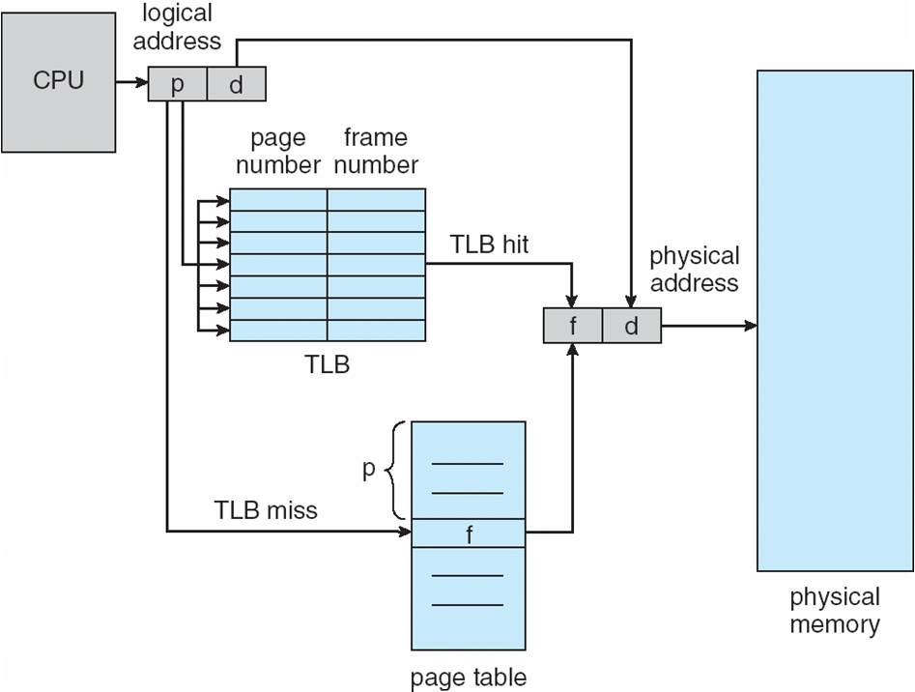
Step 1: Process starts execution
When the CPU starts running a process (for example, P1):
- The operating system sets a special register called PTBR (Page Table Base Register)
→ This register stores the starting address of the page table in memory
- So now:
  - PTBR → points to page table of P1
- Another register called PTLR (Page Table Length Register)
→ Stores the number of entries in the page table
→ Used to check if a page number is valid
Step 2: CPU generates a logical address
Whenever CPU needs data or an instruction:
- It generates a logical address (also called virtual address)
→ This is not the real memory address
- This logical address is divided into:
  - Page number (p) → tells which page
  - Offset (d) → exact position inside that page
So:
→ Logical address = (p, d)
Step 3: Check TLB first (fast memory)
- CPU first checks TLB (Translation Lookaside Buffer)
→ A small, fast cache that stores recent page → frame mappings
Case 1: TLB Hit
- If page number (p) is found in TLB:
  - TLB directly gives frame number (f)
→ Frame = location in physical memory
- Then:
  - Combine frame (f) + offset (d)
→ This forms the physical address (actual RAM address)
- Memory is accessed directly (fast)
Case 2: TLB Miss
- If page is not in TLB:
→ Need to check the page table
Step 4: Access page table using PTBR
- CPU uses:
  - PTBR (starting address of page table)

    - page number (p)
→ This locates the required entry in the page table
- Each entry is called a Page Table Entry (PTE)
→ It contains the frame number (f)
Step 5: Get frame number
- From the page table:
→ We get frame number (f)
Step 6: Update TLB
- Since this mapping was not in TLB:
  - It is now stored in TLB
→ So next time it becomes faster (TLB hit)
Step 7: Form physical address
- Combine:
  - Frame number (f)
  - Offset (d)
→ Physical address = (f, d)
→ This is the real address in RAM
Step 8: Access memory
- Using the physical address:
→ CPU fetches data/instruction from memory
Step 9: Understand the delay (important)
Without TLB:
- Access page table
- Access memory
→ This is called the two memory access problem
With TLB:
→ Usually only 1 access (faster)
Step 10: Context switch (process change)
When CPU switches from one process to another (P1 → P2):
- PTBR is updated
→ Now points to page table of P2
What happens to TLB?
- If no ASID (Address Space Identifier):
  - TLB is cleared (flushed)
- If ASID is used:
  - Each entry has process ID
→ Multiple processes can share TLB safely
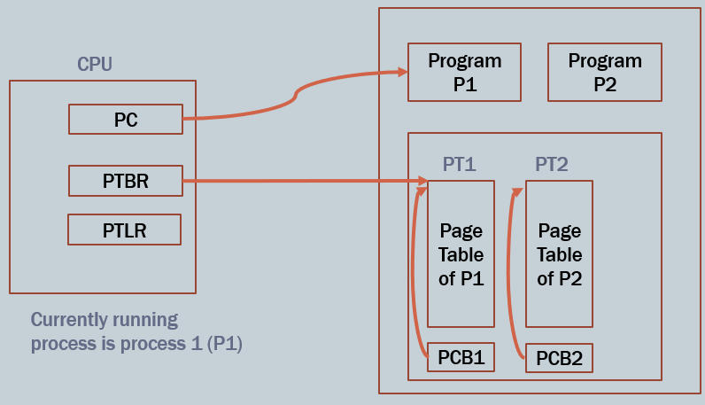
Final Understanding (in one flow)
- CPU runs process → PTBR points to its page table
- Logical address (p, d) is generated
- TLB is checked:
  - Hit → fast
  - Miss → use page table
- Page table gives frame
- Combine (f, d) → physical address
- Access memory
- On process switch → PTBR changes

Effective Access Time (EAT)
Concept
Effective Access Time (EAT) is the average time required to access memory when using TLB.
- Memory access time = 1 microsecond
→ Time to access main memory once
- Associative lookup time (ε)
→ Time taken to search in TLB
- Hit ratio (α)
→ Probability that page is found in TLB
→ Example: α = 0.8 means 80% hits
Flow of Access
Case 1: TLB Hit (probability = α)
Steps:
- Check TLB → takes ε time
- Access memory → takes 1 time
Total time = (1 + ε)
Case 2: TLB Miss (probability = 1 − α)
Steps:
- Check TLB → ε
- Access page table → 1
- Access memory → 1
Total time = (2 + ε)
Final Formula
$$EAT=(1+ε)α+(2+ε)(1-α)$$
Simplified Form
$$EAT=2+ε-α$$
EAT = 2 + TLB lookup time (ε) − TLB hit ratio (α)

Memory Protection
Concept
Memory protection ensures that:
- A process only accesses its own memory
- Prevents illegal or unauthorized access
Protection using Frame Bits
- Each frame has a protection bit
- It defines:
  - Read-only access
  - Read-write access
Valid – Invalid Bit (important)
Each page table entry has a bit:
Valid Bit
- Page is:
  - Part of process memory
  - Safe to access
Invalid Bit
- Page is:
  - Not part of process
  - Access is illegal
Flow of Protection Check
- CPU generates logical address
- Page table entry is checked
If Valid:
- Continue normal execution
If Invalid:
- Trap (error/exception) occurs
- OS handles illegal access
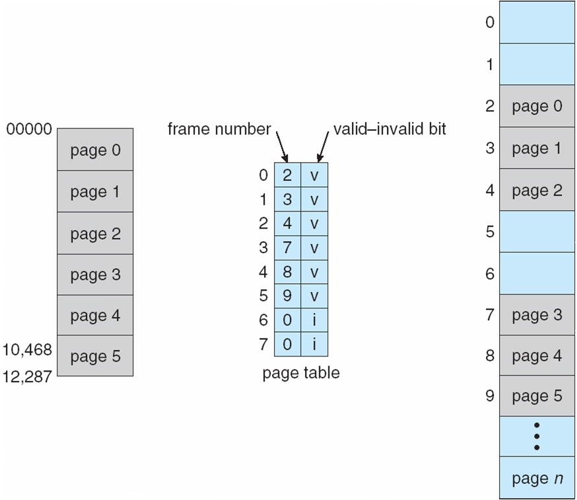

Shared Pages
Concept
Shared pages allow multiple processes to use the same physical memory for some parts of their code/data.
1. Shared Code
Definition
- Only one copy of code is kept in memory
- This code is read-only (reentrant)
→ Reentrant means it can be safely used by multiple processes at the same time
Key Points
- Shared among multiple processes (e.g., editors, compilers)
- Saves memory (no duplication)
- Similar to threads sharing same code
- Can also support interprocess communication (if writable pages allowed)
Important Condition
- Shared code must be mapped at the same logical address in all processes
2. Private Code and Data
Definition
- Each process has its own separate copy
Key Points
- Not shared
- Can be modified independently
- Can be placed anywhere in logical address space
Diagram Explanation What is shown
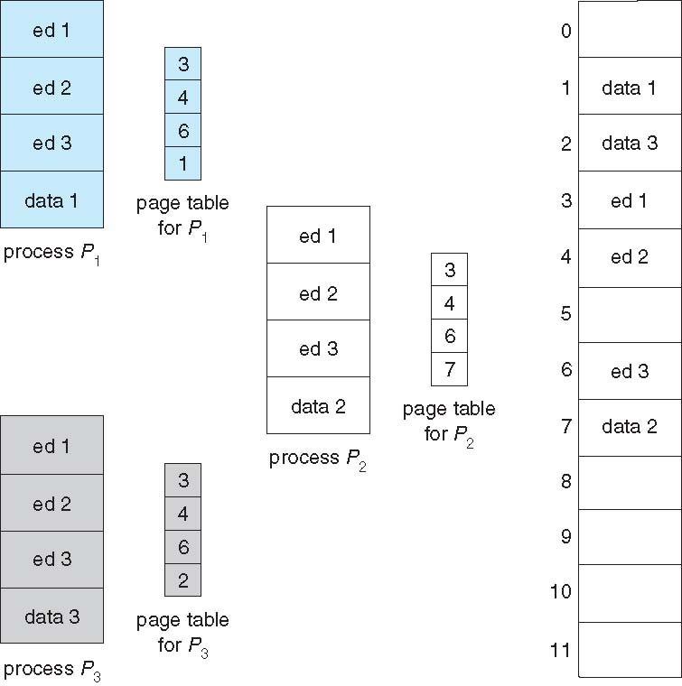
There are 3 processes:
- P1
- P2
- P3
Each has:
- Its own page table
- But some pages are shared
Step-by-Step Flow
Step 1: Identify shared code pages
Pages:
- ed1, ed2, ed3 → shared code
Observation:
- All processes use same values:
  - Frame 3 → ed1
  - Frame 4 → ed2
  - Frame 6 → ed3
Meaning:
→ These pages are stored only once in physical memory
Step 2: Page tables mapping (important)
Each process has its own page table:
For P1:
- ed1 → frame 3
- ed2 → frame 4
- ed3 → frame 6
- data1 → frame 1
For P2:
- ed1 → frame 3
- ed2 → frame 4
- ed3 → frame 6
- data2 → frame 7
For P3:
- ed1 → frame 3
- ed2 → frame 4
- ed3 → frame 6
- data3 → frame 2
Step 3: What is shared vs private
Shared:
- ed1, ed2, ed3
→ Same frames used by all processes
Private:
- data1, data2, data3
→ Different frames for each process
Step 4: Memory saving
Instead of:
- 3 copies of ed1, ed2, ed3
We have:
- Only 1 copy each
→ Huge memory saving

Two-Level Paging
Instead of one large page table:
- The page table is divided into multiple smaller tables
- This saves memory
Address Format (from diagram)
Logical address is divided into:
- p₁ (outer page number) → 12 bits
- p₂ (inner page number) → 10 bits
- d (offset) → 10 bits
So:
→ Logical address = (p₁, p₂, d)

Two-Level Paging Diagram Explanation
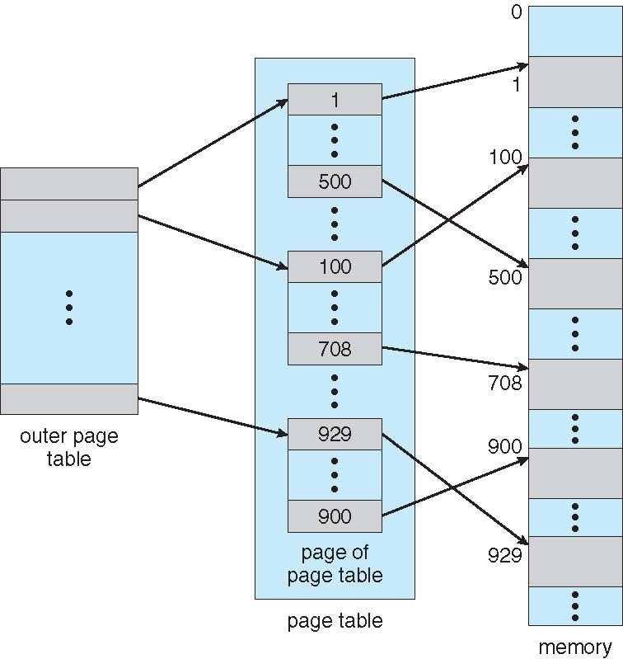
Step 1: Start from logical address
- The process has a logical address
- It is divided into:
  - p₁ → outer page table index
  - p₂ → inner page table index
  - d → offset
Step 2: Go to Outer Page Table (left side)
- Use p₁
- This selects one entry in the outer page table
That entry contains:
→ Address of a page of page table (inner page table)
(Shown by arrows going from outer table to middle structure)
Step 3: Go to Inner Page Table (middle)
- Now use p₂
- This selects an entry inside the chosen inner page table
That entry gives:
→ Frame number (like 1, 100, 500, 708, 929, etc.)
Step 4: Go to Physical Memory (right side)
- Frame number points to a location in memory
- This is shown by arrows going to memory blocks
Step 5: Use Offset
- Offset (d) selects exact data inside that frame
What the Diagram is Showing Overall
- First, the outer page table is used
→ to find the location (base address) of the inner page table
- Then, the inner page table is used
→ to find the frame number (physical location)
- Finally:
→ combine frame number + offset → physical address
The diagram below is simpler version of concept explained above:
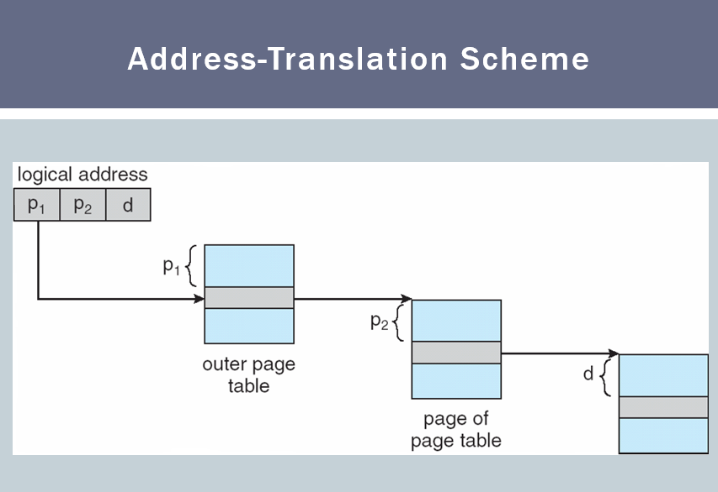

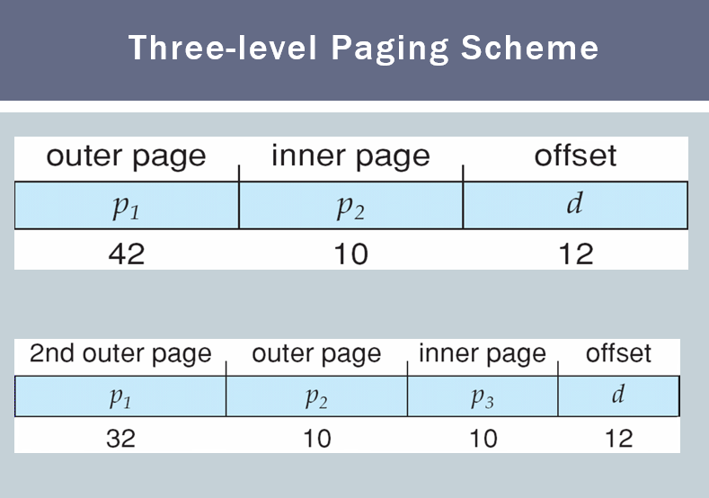
What the Diagram Shows
It shows how a logical address is divided when we increase paging levels.
First Case (Top Part)
Address is divided into:
- p₁ (outer page) → 42 bits
- p₂ (inner page) → 10 bits
- d (offset) → 12 bits
So:
→ Logical address = (p₁, p₂, d)
This is basically two-level paging, but:
- Outer part (p₁) is still very large (42 bits)
→ So page table is still too big
Why Problem Occurs
- 42 bits means:
$$2^{42}\text{ entries}⇒\text{very huge table}$$
→ Not practical
Second Case (Bottom Part → Three-Level Paging)
To fix this, p₁ is divided further:
Now address becomes:
- p₁ (2nd outer page) → 32 bits
- p₂ (outer page) → 10 bits
- p₃ (inner page) → 10 bits
- d (offset) → 12 bits
So:
→ Logical address = (p₁, p₂, p₃, d)
What This Means
Instead of:
- Outer → Inner → Memory
Now we have:
- Level 1 → Level 2 → Level 3 → Memory
Flow (How it works)
- Use p₁ → go to first-level page table
- Use p₂ → go to second-level page table
- Use p₃ → go to third-level page table
- Get frame number
- Use d → access actual data
Key Idea
- We keep dividing page tables into smaller levels
- This avoids creating a huge single page table
Why Three-Level Paging?
- To handle very large address spaces
- To save memory
- Only required parts of page tables are created

Hashed Page Tables
1. Why Hashed Page Tables Are Needed
In large systems (especially 64-bit systems):
- Address space is very large
- Traditional page tables become:
  - Too big
  - Waste a lot of memory
Solution:
→ Use hashed page tables to reduce size and improve lookup
2. Basic Idea
- Instead of directly indexing a page table
- We use a hash function on the virtual page number
So:
→ VPN (p) → Hash function → Index in hash table
3. Components Involved
(a) Logical Address
- Generated by CPU
- Divided into:
  - p → virtual page number (VPN)
  - d → offset
(b) Hash Function
- Takes p (VPN) as input
- Produces an index in hash table
(c) Hash Table
- Array-like structure
- Each index contains a linked list (chain)
(d) Chain (Linked List)
Each node contains:
- Virtual Page Number (VPN)
- Frame Number (physical page)
- Pointer to next node

Complete Working (Step-by-Step Flow)
Step 1: CPU Generates Logical Address
- Logical address = (p, d)
- Example:
  - p = page number
  - d = offset inside page
Step 2: Apply Hash Function
- Pass p to hash function
- Output → index in hash table
Example:
$$hash(p)=i$$
Step 3: Access Hash Table
- Go to index i in hash table
- At this location:
→ A linked list (chain) is present
Why chain?
→ Because multiple page numbers can hash to same index (collision)
Step 4: Search in Chain (Core Step)
This is the most important step.
Process:
- Start from first node in linked list
- Compare:
  - Stored VPN in node
  - With required page number (p)
If NOT equal:
- Move to next node
- Continue traversal
If MATCH found:
- Stop searching
- Extract frame number
If End of Chain Reached:
- No match found
→ Page Fault occurs
Step 5: Get Frame Number
- From matched node:
→ retrieve frame number (r)
Step 6: Form Physical Address
- Combine:
  - Frame number (r)
  - Offset (d)
$$\text{Physical Address}=(r,d)$$
Step 7: Access Physical Memory
- Use physical address
- Access actual data

Collision Handling
- Multiple VPNs can map to same hash index
- Stored in linked list (chaining)
So:
- Hash function → gives starting point
- Linked list → resolves collisions
Important Observations
- Hashing reduces search space
- But still requires:
  - linear search inside chain
- Performance depends on:
  - Quality of hash function
  - Length of chains

Inverted Page Table
1. Basic Idea
- Instead of:
→ one page table per process
- We use:
→ one global page table for entire system
2. Key Concept
- Normal paging:
→ indexed by virtual page number
- Inverted paging:
→ indexed by physical frames
So:
→ One entry per frame (not per page)
3. Structure of Entry
Each entry stores:
- Process ID (pid) → which process owns the page
- Virtual Page Number (p) → which page is stored
- (implicitly) frame number = index of entry
4. Why “Inverted”?
Because mapping is reversed:
- Normal:
→ Page → Frame
- Inverted:
→ Frame → Page

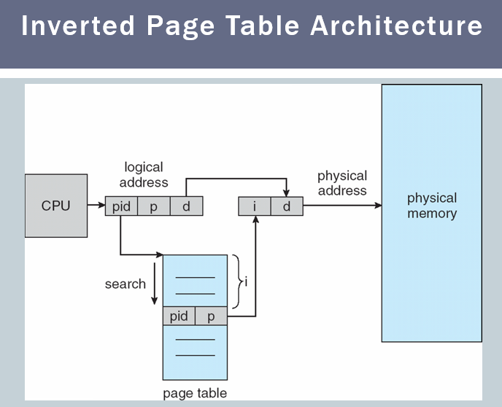
Inverted Page Table – Working
Step 1: CPU generates logical address
From the diagram:
logical address = (pid, p, d)
- pid → process ID
- p → page number
- d → offset
Step 2: Go to inverted page table and start search
- The inverted page table is shown as a single table
- Each entry contains:
(pid, p)
- The system starts searching the table from top
How search happens:
- Compare (pid, p) from CPU with:
  - Entry 0 → match?
  - Entry 1 → match?
  - Entry 2 → match?
  - …
- This continues until a match is found
So yes:
- It is a sequential/linear search
- Every entry is checked one by one
Step 3: Match is found → how frame number is obtained
From the diagram:
- When a match is found at some position in the table:
index = i
- That position (i) is the frame number
Important:
- The frame number is not stored separately
- The index of the entry itself = frame number
Step 4: Form physical address
Now:
- Frame number = i
- Offset = d
So:
physical address = (i, d)
Step 5: Access physical memory
- The physical address (i, d) is sent to memory
- Memory returns the required data
Final Flow (Exact Diagram Logic)
- CPU → generates (pid, p, d)
- Go to inverted page table
- Search entry by entry for matching (pid, p)
- When found at index i → frame number = i
- Combine (i, d) → physical address
- Access memory

Segmentation
Definition
- Segmentation is a memory management scheme that matches how users think about memory.
- Instead of fixed-size pages, memory is divided into variable-sized segments.
Key Idea
- A program is divided into logical parts called segments.
Each segment represents a meaningful unit like:
- main program
- procedure / function
- object
- local variables / global variables
- stack
- symbol table
- arrays
Important Characteristics
1. Logical division
- Segments are based on program structure, not size.
- Each segment has a name and purpose.
2. Variable size
- Unlike paging, segments are not equal in size.
3. User view
- Matches how a programmer thinks:
  - “this is a function”
  - “this is a stack”
  - “this is data”
Address Format in Segmentation
Logical address:
(segment number, offset)
- Segment number → which segment
- Offset → position inside that segment
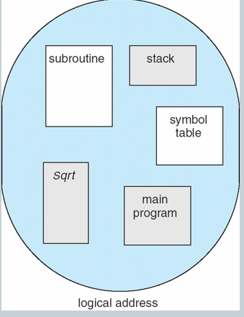
User’s View of a Program
What the diagram shows
The circle represents:
- Entire logical address space of a program
Inside it, different blocks represent segments:
- subroutine
- stack
- symbol table
- main program
- sqrt (function)
Logical View of Segmentation
Left Side: User Space (Logical View)
- The circle represents logical address space of a program
- Inside it, blocks labeled 1, 2, 3, 4 are segments
These segments:
- Are separate logical units
- Can be:
  - Segment 1 → main program
  - Segment 2 → function
  - Segment 3 → stack
  - Segment 4 → data
Important:
- They are not ordered
- They are scattered logically
Right Side: Physical Memory
- This shows actual RAM
- Segments are placed anywhere in memory
- Order is different from logical view:
Example from diagram:
- Segment 1 → placed at top
- Segment 4 → placed next
- Segment 2 → placed later
- Segment 3 → placed below
So:
- Logical order ≠ Physical order
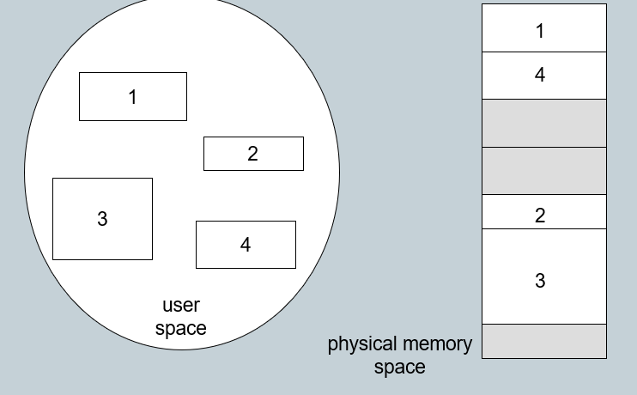
Flow: How Mapping Happens
Step 1: CPU generates logical address
(segment number, offset)
Example:
- (2, 50) → 50th location inside segment 2
Step 2: Use segment number to access segment table
- Segment table stores:
  - Base address → where segment starts in physical memory
  - Limit → size of segment
Step 3: Find segment location in physical memory
- Using segment number:
  - OS finds where that segment is placed in RAM
Example:
- Segment 2 → located somewhere in middle of memory
Step 4: Add offset
Physical address = base + offset
Step 5: Access memory
- Final address is used to fetch data
Key Concept from Diagram
1. Segments are scattered
- Segments are not contiguous
- Each segment can be placed anywhere
2. Logical vs Physical difference
- Logical: organized, meaningful
- Physical: scattered, optimized
3. No fixed size
- Segments are variable-sized

Segmentation Architecture
1. Logical Address Format
Logical address is divided into:
(segment number, offset)
- Segment number (s) → identifies which segment
- Offset (d) → position inside that segment
2. Segment Table
- Each process has a segment table
- It maps logical addresses to physical addresses
Each entry contains:
(a) Base
- Starting physical address of the segment
- Tells where the segment is located in memory
(b) Limit
- Size (length) of the segment
- Used for bounds checking
3. Registers Used
Segment Table Base Register (STBR)
- Points to the starting address of segment table in memory
Segment Table Length Register (STLR)
- Stores number of segments in the program
Condition:
segment number s is valid if s < STLR
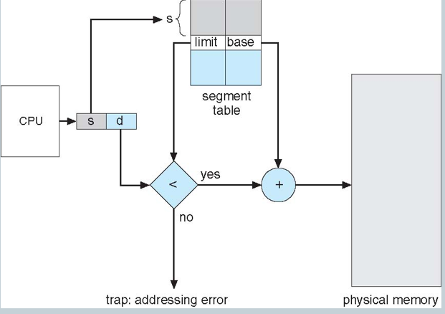
Segmentation Workflow (From Diagram)
Step 1: CPU generates logical address
- CPU produces:
(s, d)
- s → segment number
- d → offset inside that segment
Step 2: Use segment number to access segment table
- The segment number s is used as an index
- It selects the corresponding entry in the segment table
From that entry, we get:
- Base → starting physical address
- Limit → size of segment
Step 3: Check offset with limit (IMPORTANT decision box)
- The diagram shows a comparison:
d < limit ?
If YES:
- Offset is valid
- Continue execution
If NO:
- Offset exceeds segment size
- System generates:
trap: addressing error
- This prevents illegal memory access
Step 4: Form physical address
If valid:
Physical Address = Base + d
- Base → where segment starts
- d → how far inside the segment
Step 5: Access physical memory
- The computed physical address is sent to memory
- Data is fetched/stored

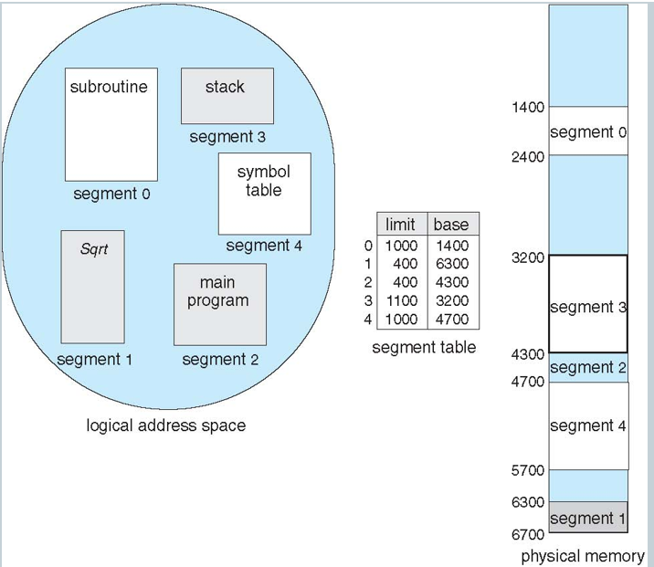
Given (from diagram)
From the segment table:
Segment | Limit | Base
3 | 1100 | 3200
So for segment 3:
- Base = 3200
- Limit = 1100
Step-by-Step Workflow
Step 1: Logical address
We are accessing:
(s = 3, d)
Step 2: Check segment table
- Go to entry for segment 3
- Get:
  - Base = 3200
  - Limit = 1100
Step 3: Check offset condition
Condition: d < 1100
- If d ≥ 1100 → ERROR (trap)
- If d < 1100 → valid
Step 4: Form physical address
If valid:
Physical Address = 3200 + d
Step 5: Locate in physical memory
From diagram:
- Segment 3 starts at 3200
- Ends at: 3200 + 1100 = 4300
So:
- Segment 3 occupies memory range: 3200 to 4299
Final Answer (What you were asked)
- Segment 3 location in physical memory:
Base = 3200
Limit = 1100
Range = 3200 → 4299
- Any logical address:
(3, d) maps to: 3200 + d
Example (for clarity)
If: (3, 200)
Then:
Physical Address = 3200 + 200 = 3400

